MSS2 平台使用指南(企業用)

MSS2 UI User Manual (Corporates)

Last Edited: 5 July 2019

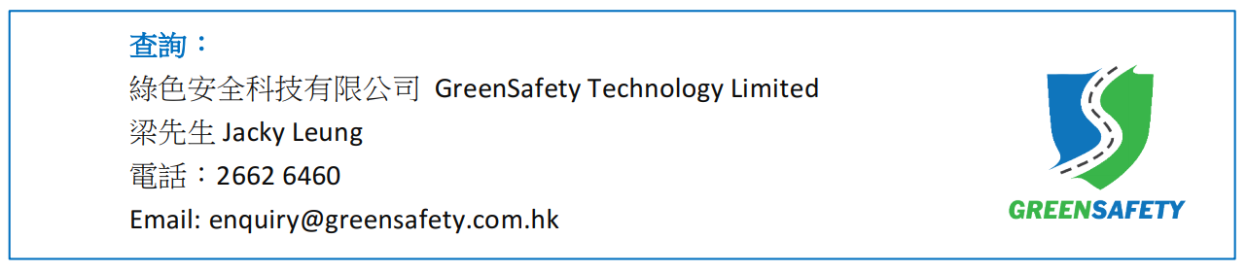

Table of Contents

User Menu 3

Account Information 3

Change Password 4

Change Language 5

Live Location 6

Warning 8

Trip Detail (Select Trips and View Warnings) 8

Trip Maintenance 17

Trip Driver Import (Input Driver Names at Once) 20

Export Warning Data 23

Warning Video Download 26

Profile 28

Setting 34

Search 35

Add Single Item 36

Add Multiple Items 37

Download as a File 38

Organization Chart Maintenance 38

Email Notification Maintenance 40

Roster 42

Abbreviations and Symbols 44

Warning Type 44

Driver Action 45

Vehicle Type 45

Appendix 46

Grading and Score 46

All Recommendations 47

# User Menu

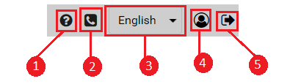

1. User Guide
2. Contact Us
3. Change Language
4. Account Information
5. Logout

## Account Information

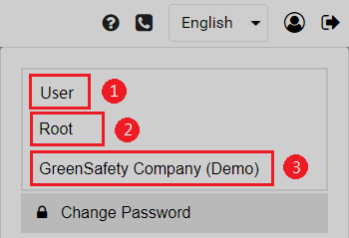

1. User name
2. Department name
3. Company name

## Change Password

1. Click on "Change Password" under .   
   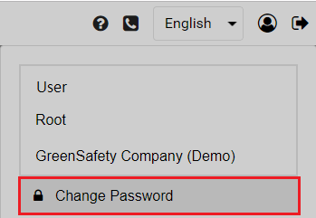
2. Fill in the form and submit your new password.   
   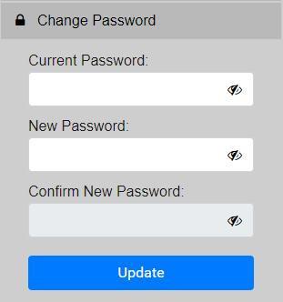

## Change Language

1. Click here to view available translations.   
   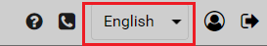
2. Select the desired language.

# Live Location

1. Click on "Live Location".   
   
2. In the filter section on the left, three car icons are shown under Running Status (GPS). Click  to check for their descriptions.   
   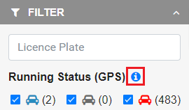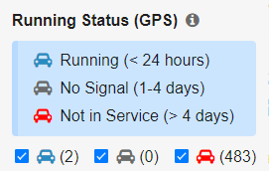
3. Next to each status, the number of count is displayed.   
   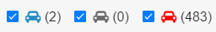  
   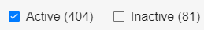
4. If you want to filter for vehicles that are online, please choose  as running status and "Active" for device status.   
   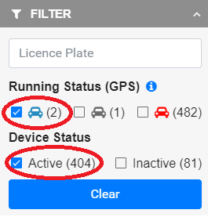
5. Hover on the marker, an info-window with details will pop up.   
   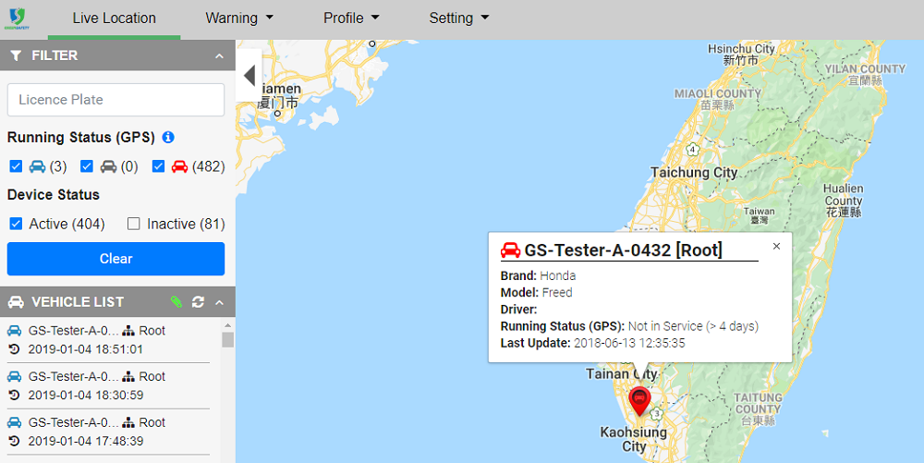
6. Select a vehicle from the vehicle list and view its live location and detail. You may also input the licence plate to search.   
   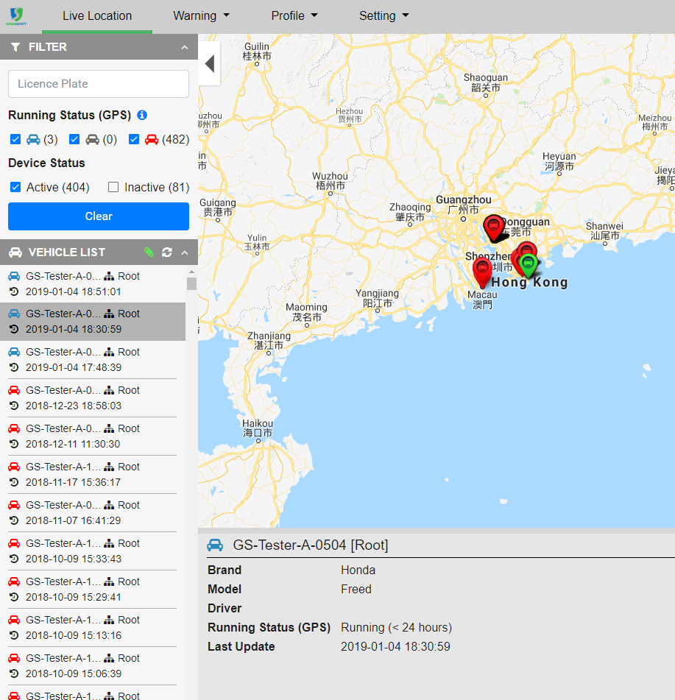
7. In the vehicle list,  indicates which department the vehicle belongs to. Check out Vehicle Type for explanation of vehicle icons。   
   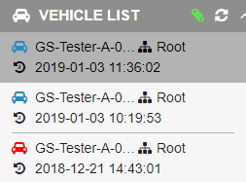

# Warning

## Trip Detail (Select Trips and View Warnings)

1. Click on "Trip Details" under "Warning" on menu bar. 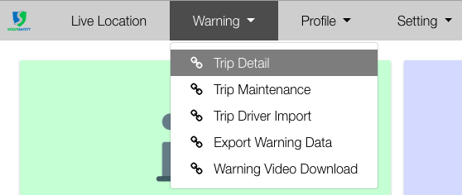
2. Select a query type. e.g "Vehicle".   
   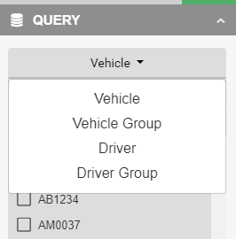
3. Select a vehicle and the date range. You may select more than one vehicle.   
   Note: Date range is allowed to select a maximum range of 1 year.   
   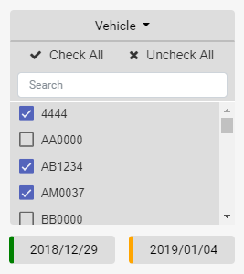
4. You can query with mileage if needed. Click  to check for the description.   
   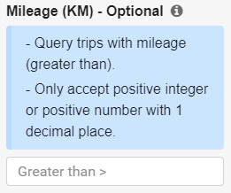
5. Click "Submit". You will get a trip list.   
   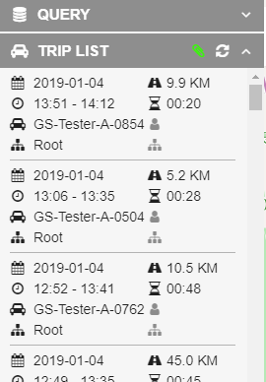
6. After selecting a trip, you may check its route on map and warnings below map. Check out Warning Type , Driver Action and Vehicle Type for more information.   
   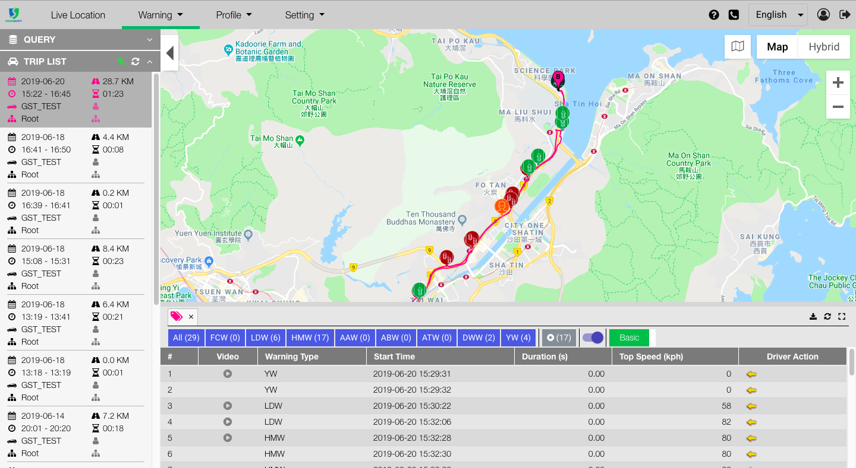
7. You may view at most 4 trips at the same time. The trips will be shown with 4 colors on map.   
   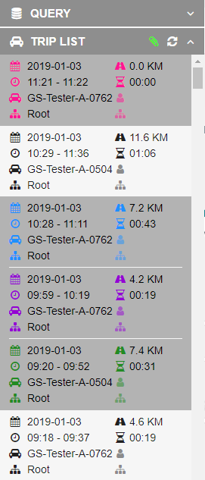

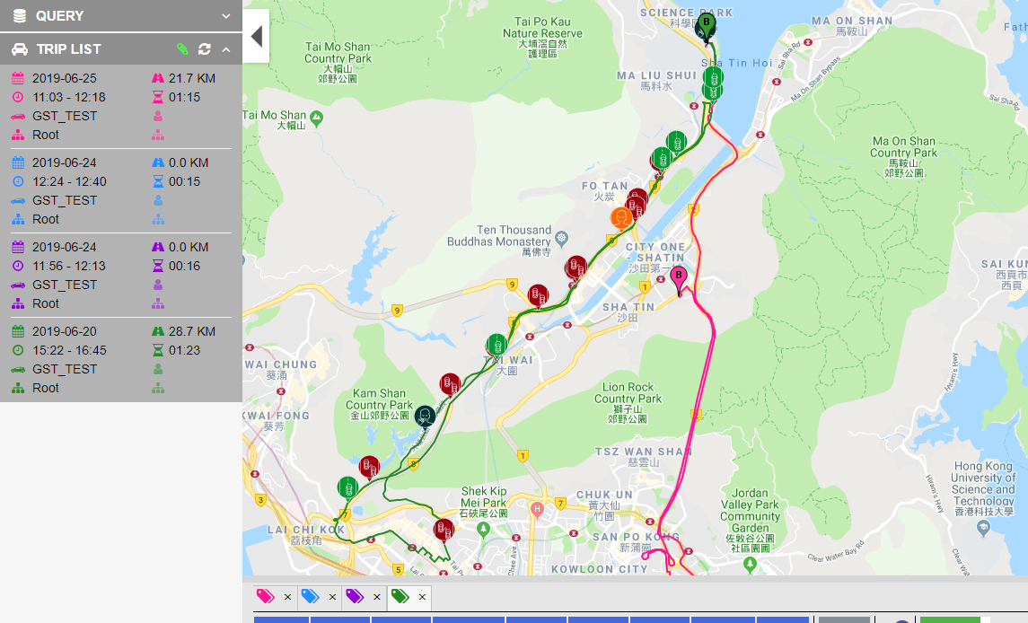

1. Click on the tabs 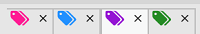and the corresponding warnings will be shown.
2. If you choose more than 4 trips, an error message box will be shown. You will have to close one tab to view other trips.   
   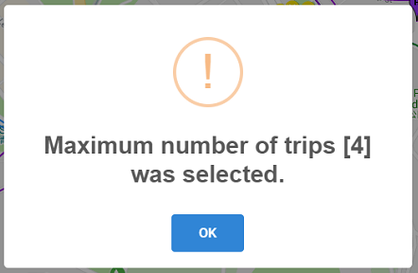
3. You can check where the warnings happened. For example,  marked where the warning happened. 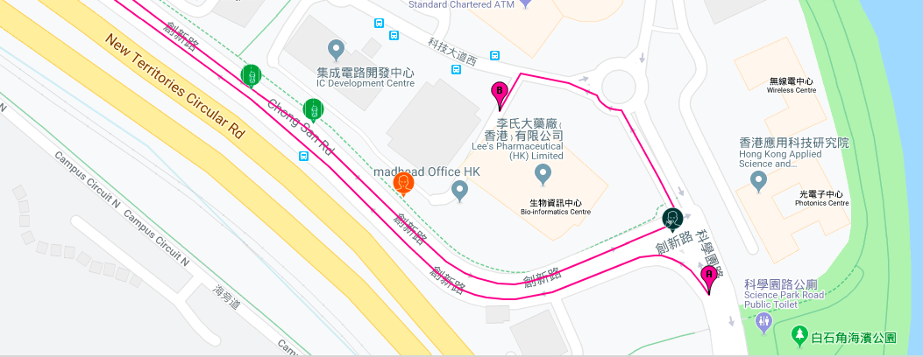
4. Click on the warning marker or the row in the table. An info-window with detail will be poped up.   
   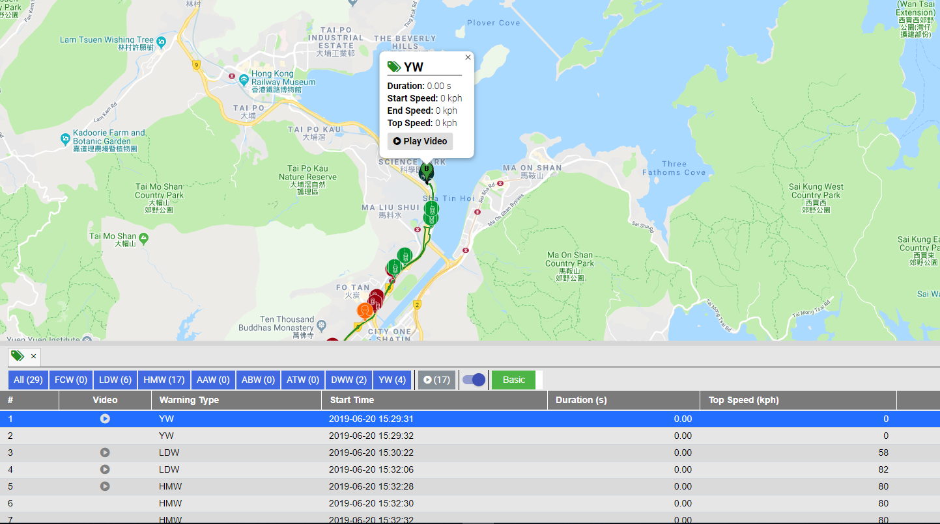
5. The list on the bottom will show the warning information. Toggle on  to the warning marker on the map.

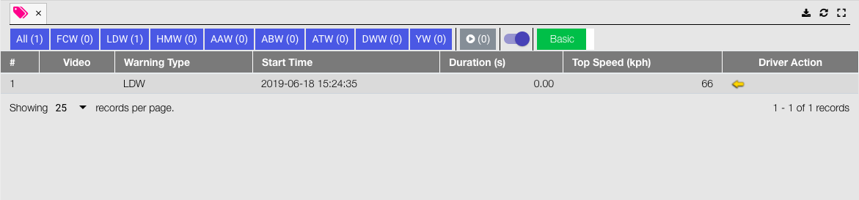

1. Users can switch from basic mode  to advanced mode  for more details of the trip. 

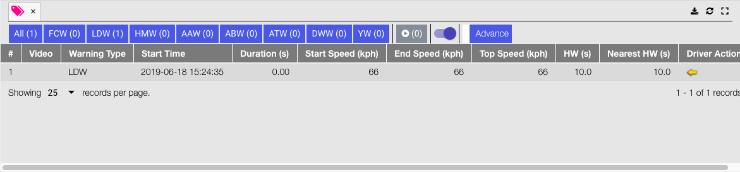

1. The content of each column are the following.

|  |  |
| --- | --- |
| **Items** | **Description** |
| Video | A play button show when the warning pre-defined to be captured the video during the warning occurred |
| Start Time | The warning starting time |
| Duration (s) | The warning start to end duration |
| Start Speed (kph) | The speed when the warning was started |
| End Speed (kph) | The speed when the warning was ended |
| Top Speed (kph) | The top speed during the warning was occurred |
| HW (s) | Headway distance to vehicle ahead (unit second) |
| Nearest HW (s) | The nearest headway distance to vehicle ahead (unit second) |
| Driver Action | The driver follow up action was taken during the warning (Turning signal/brake, etc). Check out [Driver Action](http://dgdsweb04/) for more information. |

1. Users can filter the warnings by clicking on the warning names. Each warning's count is next to the name.   
   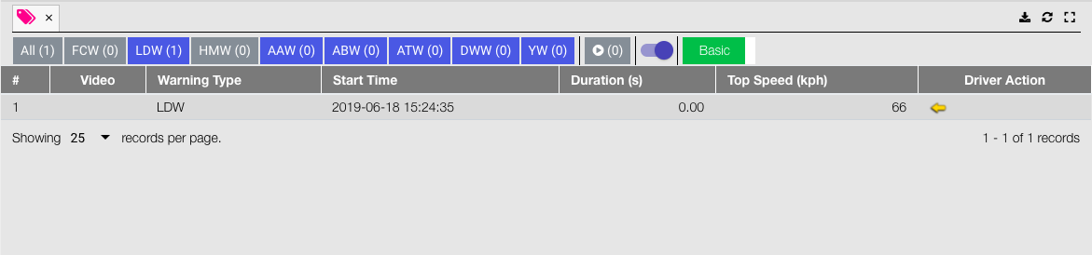
2. You can select  to view records with videos.

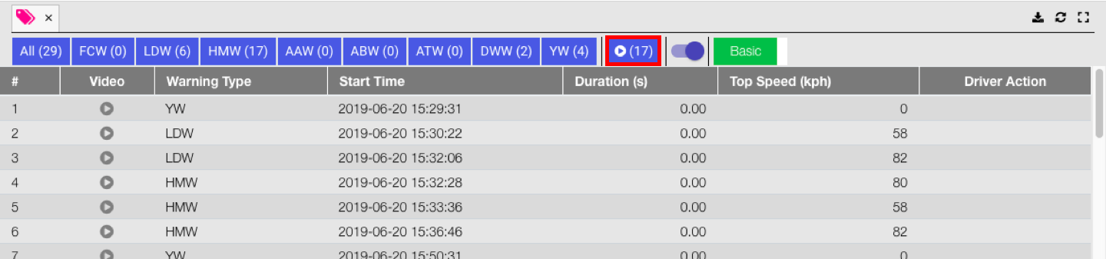

1. If  is shown in warning details, video is attached. You may click on  to watch the video. If  is shown, an video is pending for upload.   
   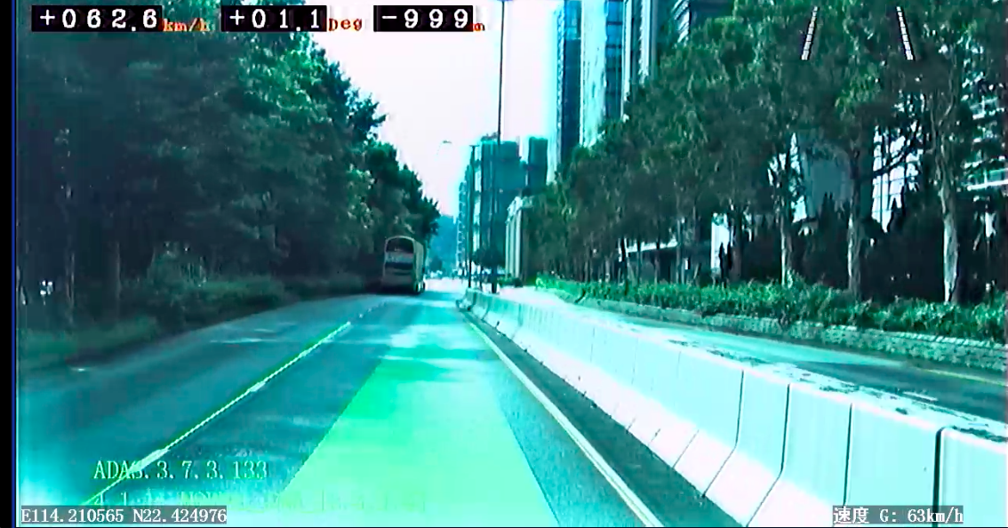
2. If you want to download the video, please click "Download" under  to start downloading the video. 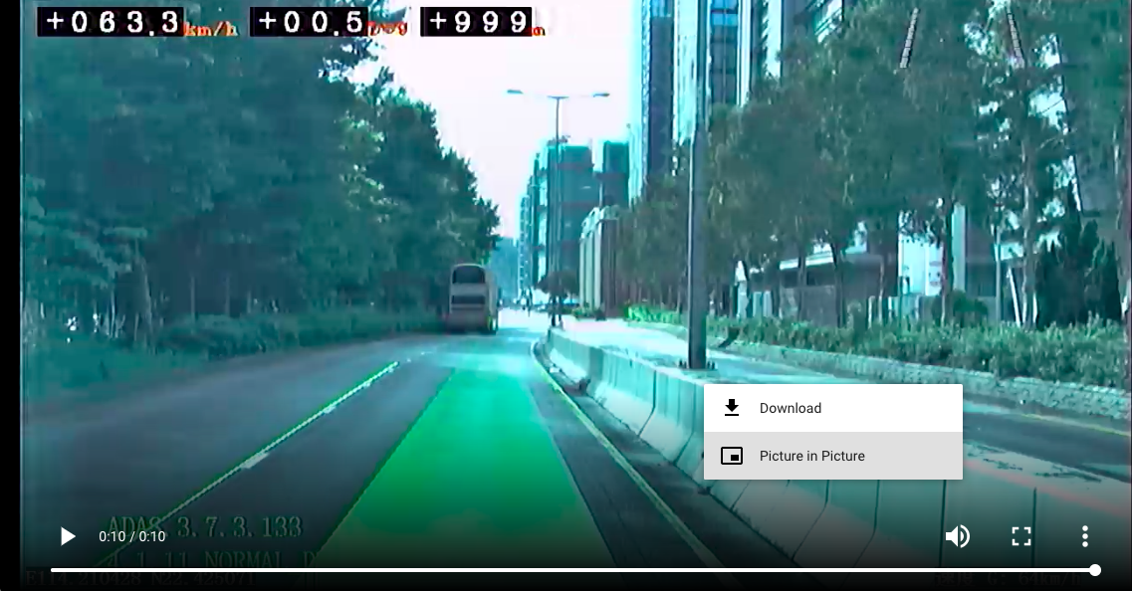
3. You may also click  to download all warning records as a CSV file. 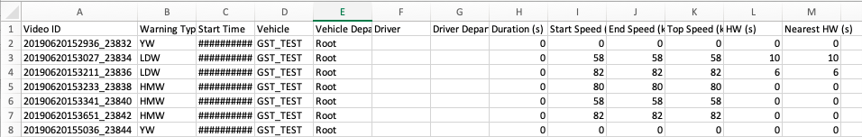

## Trip Maintenance

1. Select "Trip Maintenance" under "Warning" on menu bar.   
   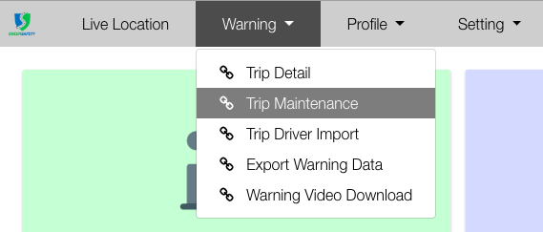
2. Select the start date, end date.   
   Note: Date range is allowed to select a maximum range of 1 year.   
   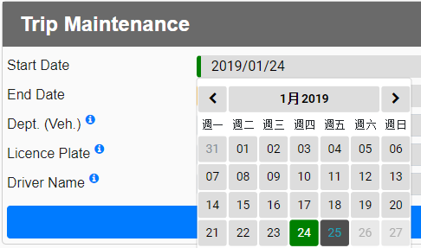  
   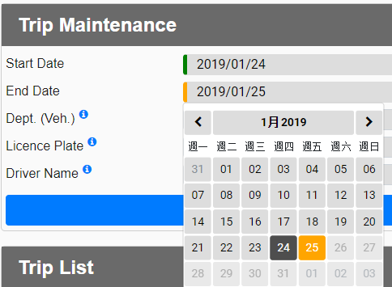
3. Select licence plate, driver department and driver name. Click  to check for the description of option.   
   Please note that you can only select one option for each field. If you want to view more, please select N/A.   
   To query trips which without driver, please select "EMPTY" for driver name.   
   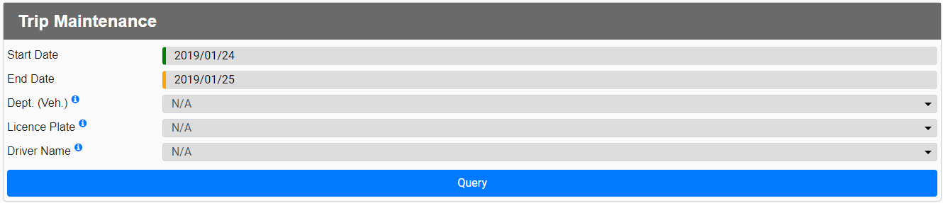
4. Click "Query". 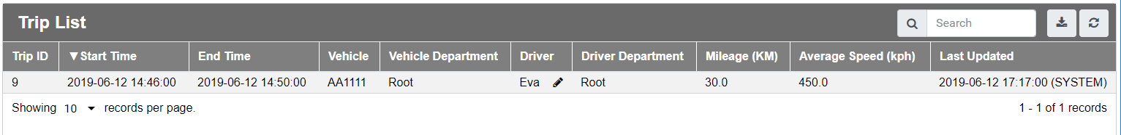
5. Click on  to input driver name.   
   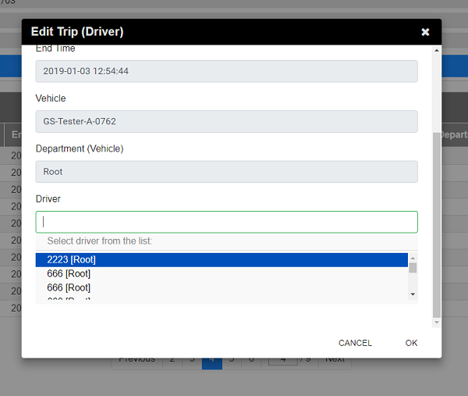
6. Confirmation message will be prompted upon successful submission.   
   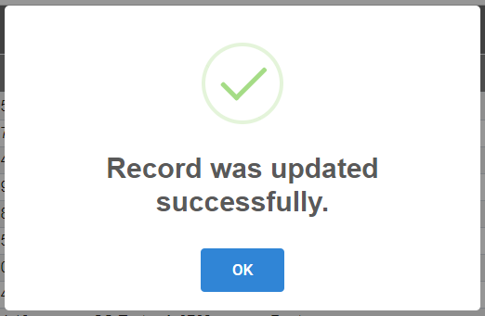

## Trip Driver Import (Input Driver Names at Once)

1. Download the queried trip list in "Trip Maintenance". Click  to download as a CSV file.

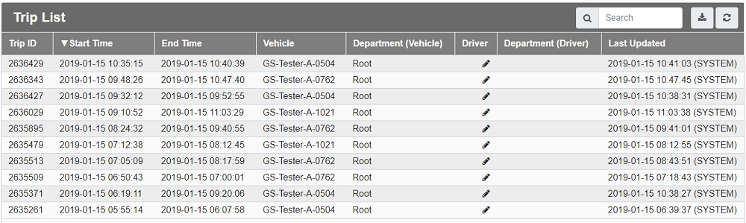

1. Open the CSV you have just downloaded.   
   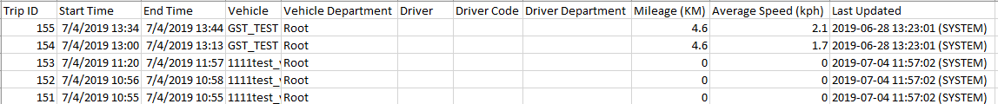
2. Key in the corresponding driver name in column G.

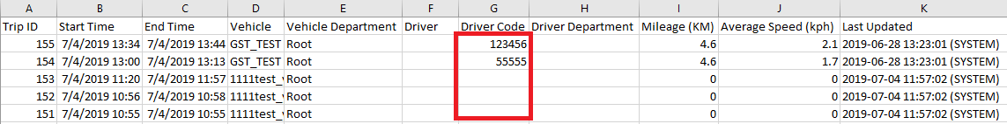

1. Enter the formula =A2&","&G2 to column L. The example below input the formula in cell L2.

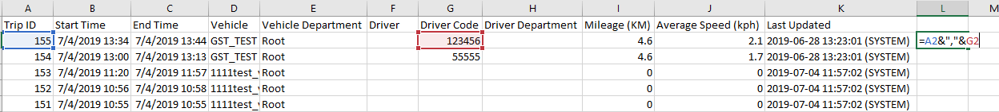

1. You may copy the formula to all rows that you want to update. Copy the code in column L. 
2. Select "Trip Driver Import" under "Warning" on menu bar.   
   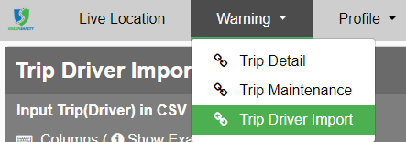
3. Paste the copied code in the textarea below. Click "Submit". Please note that you can only put one code for a line. New a line for another record.

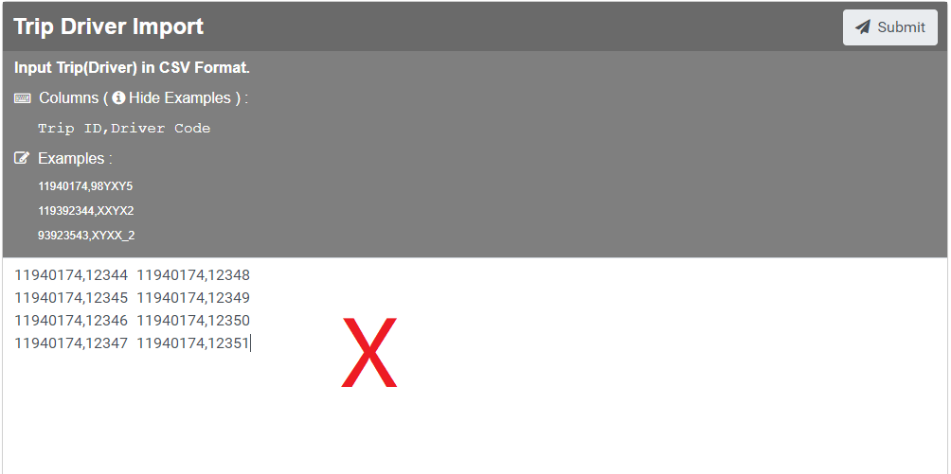

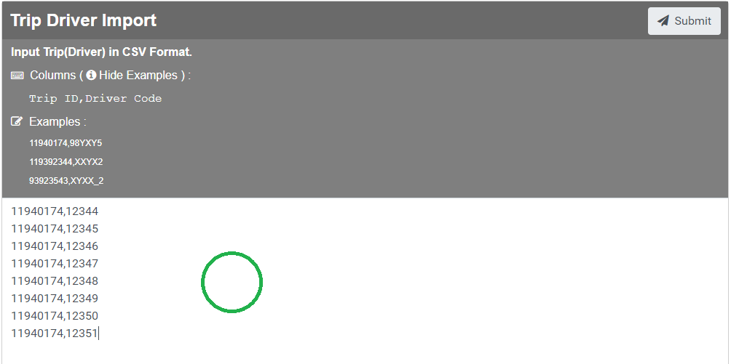

1. Confirmation message will be prompted upon successful submission.   
   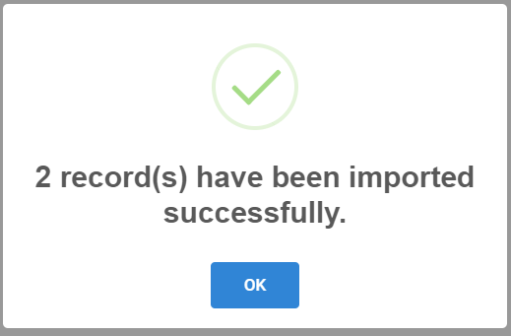

## 

## Export Warning Data

1. Select "Export Warning Data" under "Warning".   
   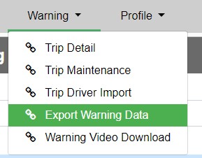
2. Enter the filename when necessary.   
   Downloaded Format will be: "< Warning Data Filename >.csv"   
   If nothing input, default values: "WarningData_< Current Date >.csv" will be used.   
   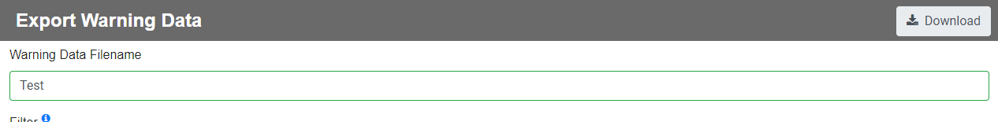
3. Click  to check for the instructions for using the filter.   
   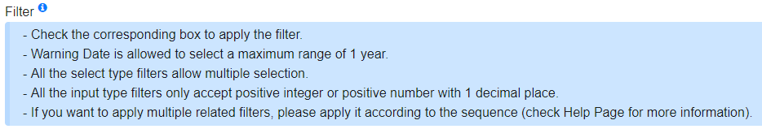
4. Select the date range of warnings that you want to download.   
   Note: Warning date is allowed to select a maximum range of 1 year.   
   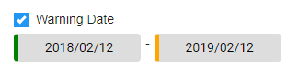
5. Select the filter(s) that you want to apply.   
   Note: If no filter is applied, all data within date range will be downloaded.   
   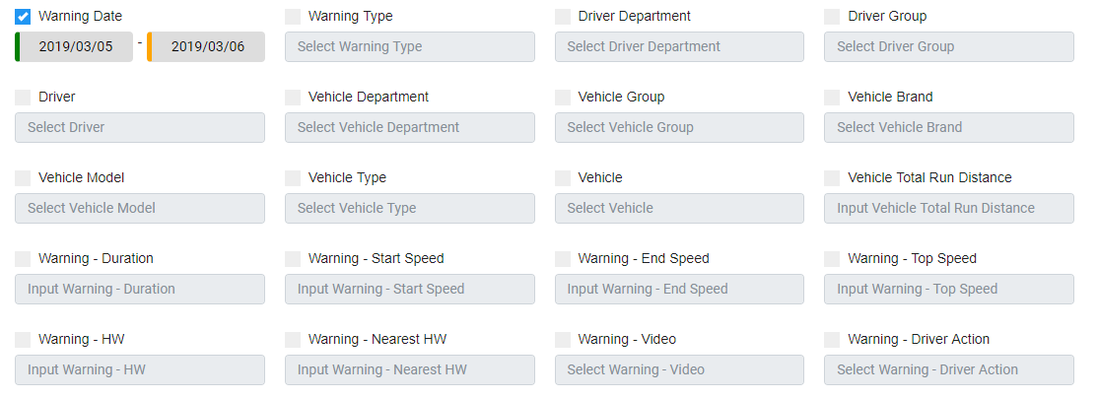
6. If you want to apply multiple related filters, please apply it according to the sequence.   
   (1) Driver Department🡪Driver Group🡪Driver   
   (2) Vehicle Department🡪Vehicle Group🡪Vehicle Brand🡪Vehicle Model🡪Vehicle Type🡪Vehicle   
   Note: The options of the last filter in the sequence will be affected by the related filter(s).
7. Input / Select the criteria of each selected filter(s) respectively.   
   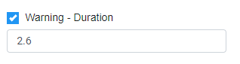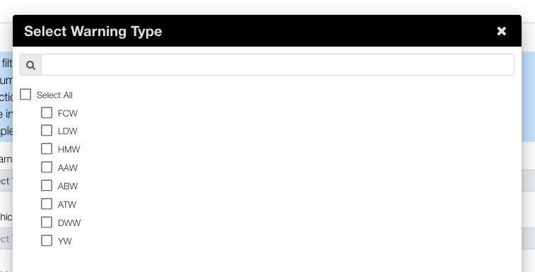
8. Click download. You can browse the warning data after opening the file.   
   

## Warning Video Download

1. You have to get the CSV of trip warnings or warning data first. Copy the video ID in the CSV. You can check out [Trip Detail](#_Trip_Detail_(Select) / Export Warning Data for more details.





1. Select "Warning Video Download" under "Warning".   
   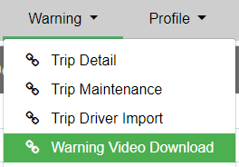
2. Enter the filename and prefix of video filename when necessary.   
   Downloaded Format will be: "< ZIP Folder Filename >.zip" and "< Video Filename Prefix >_< Video ID >.mp4"   
   If nothing input, default values: "VideoArchive_< Current Date >.zip" and "< Video_ID >.mp4", will be used.   
   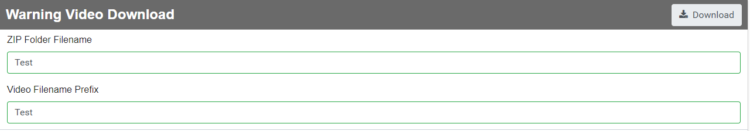
3. Enter the video ID of the videos that you wanted to download. If there is more than one ID, please put them line by line. Click download.   
   Note: Maximum accept 50 Video ID(s).   
   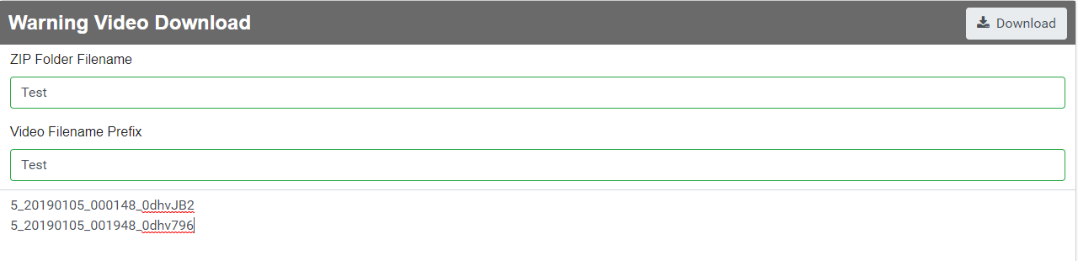
4. Unzip the downloaded file.   
   Note: If there is an error in some of the video ID, a file "ERROR_ID.txt" will be generate in the ZIP folder, which will contains the wrong video ID.

# Profile

1. Select the profile you want to view under "Profile".   
   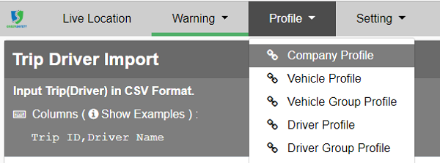
2. If you want to check out the company profile, please decide whether to view the company profile by date, week, month or year and click "submit".   
   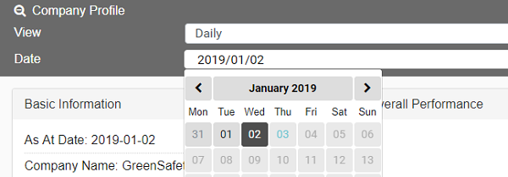  
   If you are looking at other profiles, please choose your target's licence plate, vehicle group, driver or driver group.   
   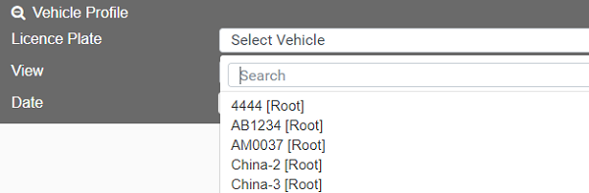
3. View Your Grade and Score
   1. Basic Information and Grade   
      **Basic Information**   
      This part would show the basic information of the target.   
      Sometimes, there is no record of the date you selected since the running distance is less than 20KM. In that case, lastest record will be displayed. "As At Date" indicates the date of the record that currently displayed.   
      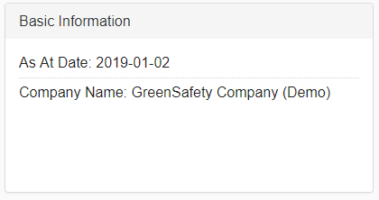  
      **Grade**   
      This part would show the target's grade. Please look at Grading and Score for details.   
      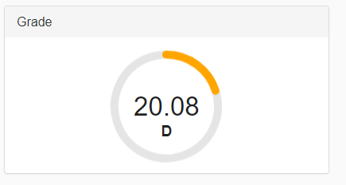  
      The grades in other profiles contains an outer circle and an inner circle. The outer circle refers the company's score with the actual number and grade in brackets at the right bottom. The inner circle refers to the target's value with actual number in the circle.   
      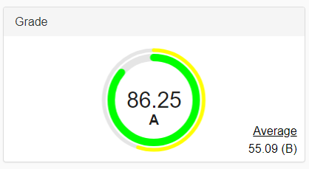
   2. Overall Performance   
      This part integrates target's performance in different warning aspects. Hover the point can view the corresponding marks. Click on the point can view the detailed list of the warnings. Check out Warning Type for more information.

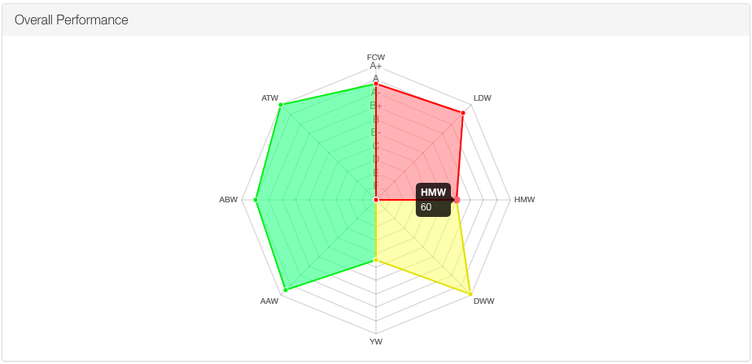

Click on  can filter records with video. If  is shown, an video is pending for upload. Click  can download records as a CSV file. Click  on can refresh the records. Click  on can exit.



* 1. Bar charts   
     You may check out bar charts for each warning. In company profile, basic bar charts are used with the numbers as the latest values.

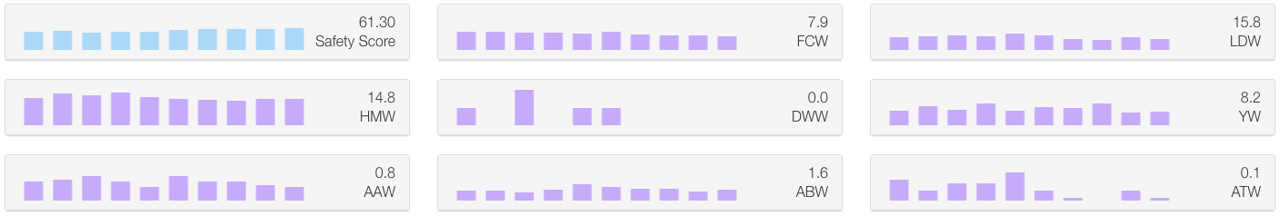

Other profiles would show a line together with the bar chart. The line shows performance of the company and the bar shows performance of the target.

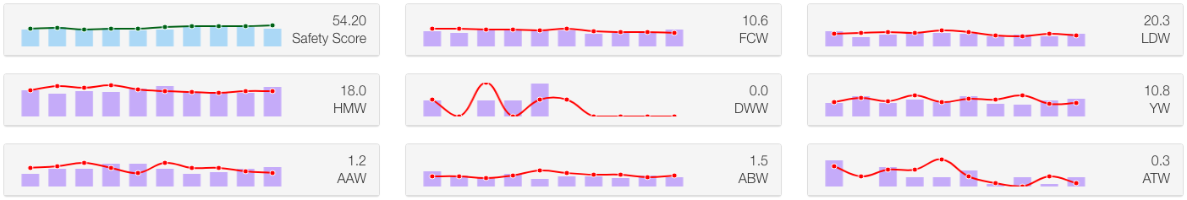

You may click to view enlarged chart.

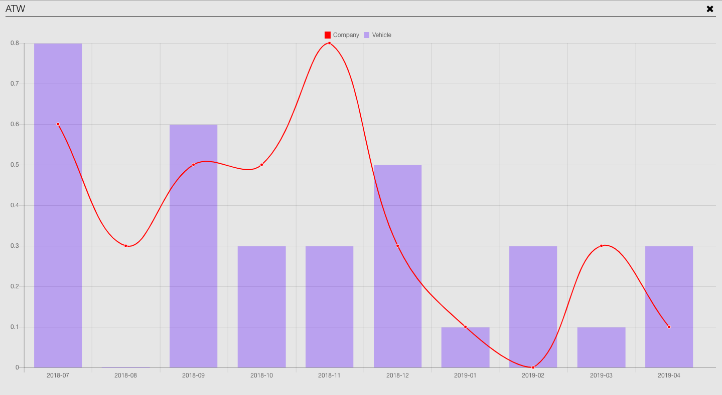

1. You may scroll down to view more information. Click to see corresponding detail records.   
   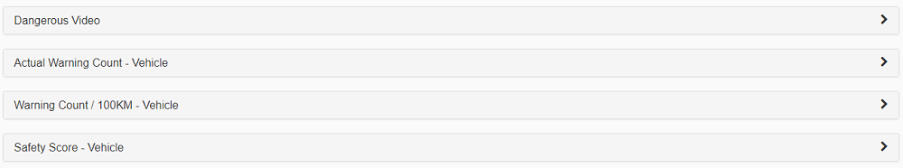
   1. Click "Dangerous Video" to view details of the dangerous driving records. Click  to download all records.   
      Click  to play videos. If  is shown, an video is pending for upload. If you want to download videos, please click "Download" under  to start download.   
      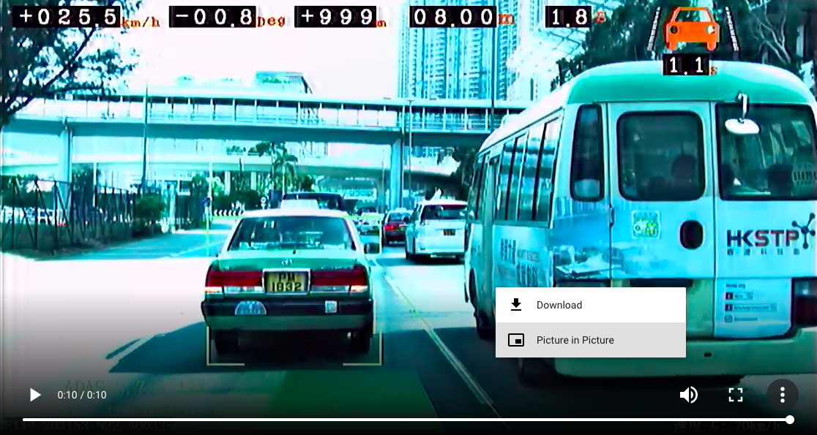
   2. On the page of company profile, you may view actual warning count, warning count/ 100KM and safety score by different roles, including company, vehicle group, vehicle, driver group, driver.   
      On other profile page, you can only view the records related to the target. Click to see record details.   
      The example below uses actual warning count as an example. Click  to download as a CSV file. Check out [Warning Type](http://dgdsweb04/) for more information.

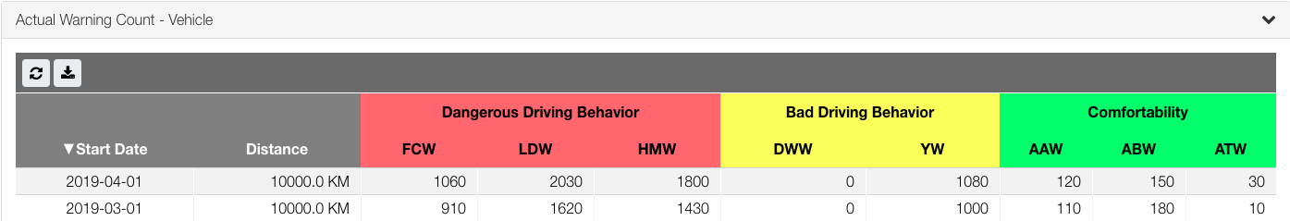

* 1. In profiles other than company profile, you may expand "Score Ranking" to check out the ranking.
  2. You may also view the line chart of the safety score, collision warning count/100 KM, bad driving behaviour warning count/100 KM and comfortability warning count/100 KM. Hover the points to check out corresponding score.

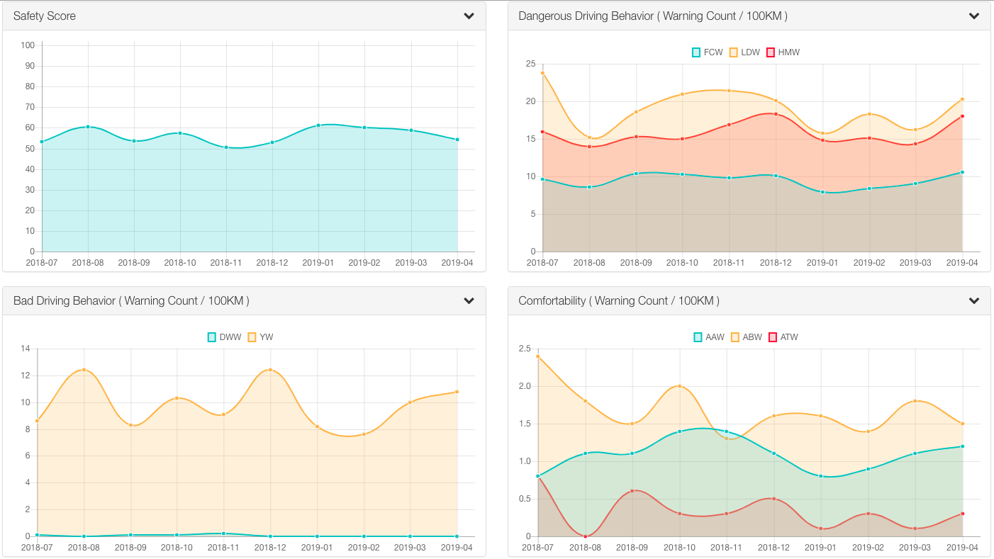

# Setting

1. Select a category in the drop-down menu of settings.

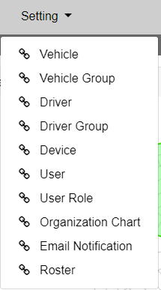

1. Corresponding information and operations would be displayed. The following uses vehicle as an example.   
   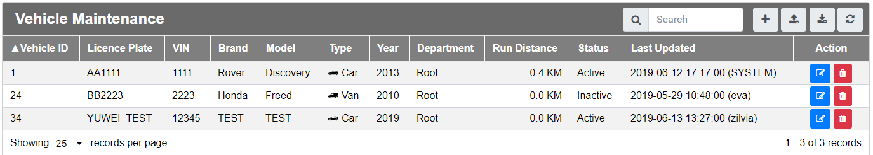
2. The following are explanations to the menu buttons.   
   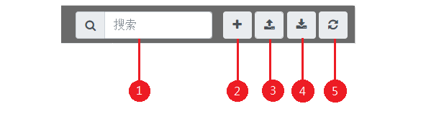
   1. Search
   2. Add single item
   3. Add multiple items **Not supported in Device, User, User Role, Organization Chart, Email Notification and Roster
   4. Download as CSV **Not supported in Roster
   5. Refresh

## Search

The following uses vehicle settings as an example. Search function in other settings pages follows.

1. Enter keywords here.   
   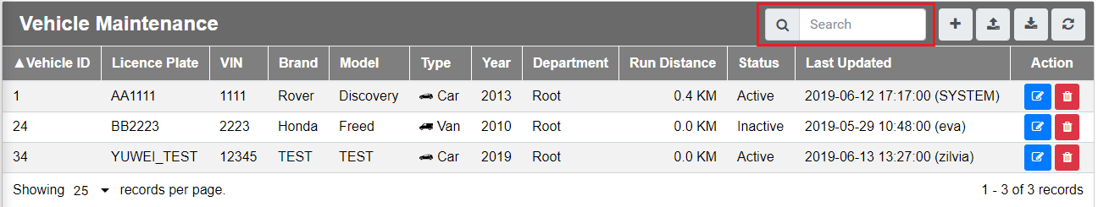
2. Information that contain the keyword would be filtered and shown. This function searches information globally without targeting any particular column. Keyword contained in any column would be displayed.   
   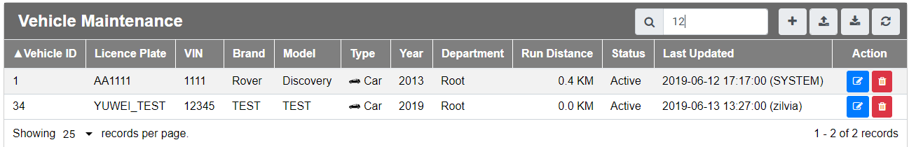

## Add Single Item

1. If you want to add a single item, please click on the "add single item" button.
2. Fill in the form and click "OK". The form content differs in different settings. The following is the form of vehicle as an example.   
   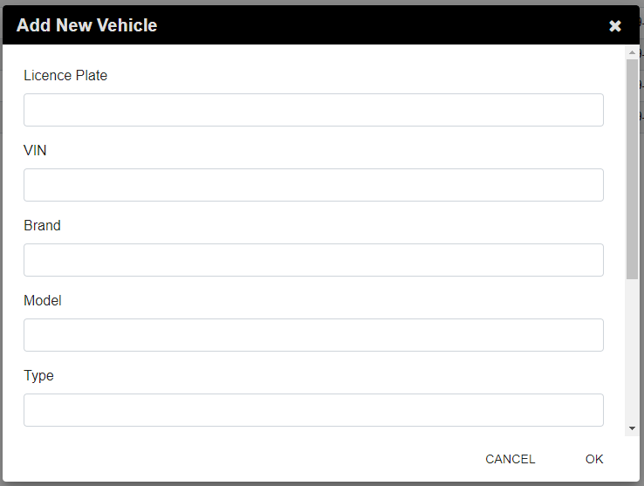
3. Confirmation messages will be prompted upon successful submission.   
   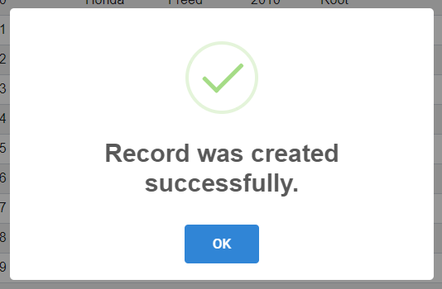

## Add Multiple Items

You may upload a single CSV file to insert multiple items. This function is limited for vehicle detail, vehicle, vehicle group, driver and driver group maintenance. Different settings has its own format and columns. Please put the data line by line. A line should contain only one item.

1. Vehicle   
   Format: < licence plate*^ >,< vehicle* >,< status* >,< department* >   
   Status value only accept 'A' or 'I'.   
   Example: GS123,(Honda)13,A,GS
2. Vehicle Group   
   Format: 1,< group name*^ >,< group descpt* >,< department* > or; 2,< group name* >,< licence plate* >   
   All addind group rows (those start with 1) should go before add vehicle rows (those start with 2).   
   Example： 1,GroupA,Testing,GS
3. Driver   
   Format: < name* >,< driver code*^ >,< staff card id >,< phone home >,< phone mobile >,< phone office >,< date of birth >,< department* >   
   Please input date of birth in the format of 'YYYY-mm-dd'.   
   Example: 28,11155,,,,,,GS
4. Driver Group   
   Format: 1,< group name*^ >,< group descpt* >,< department* > or; 2,< group name* >,< driver name* >   
   All adding group rows (those start with 1) should go before adding driver rows (those start with 2). If there are drivers with same name, only the first one will be added to group.   
   Example： 2,GroupA,28

Click on the upload icon, select your file and click "open".

* required fields

^ unique fields

## Download as a File

You can download all data as a CSV file. Click the download icon and download will start.

In Organization Chart settings, a PNG image file will be downloaded.   
The following is an downloaded example of vehicle.



## Organization Chart Maintenance

1. Select "Organization Chart" under "Settings".   
   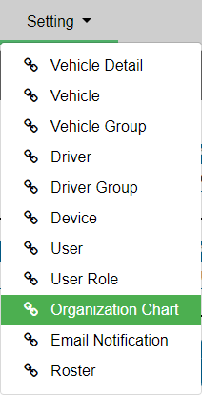
2. Hover to each department block can view the possible expand or collapse directions.   
   Note: Each department can only view/add/edit the data belongs to it or belongs to the departments under it.   
   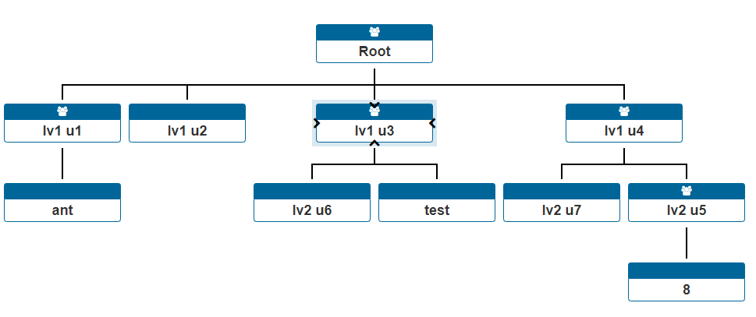
3. Click to view department details.   
   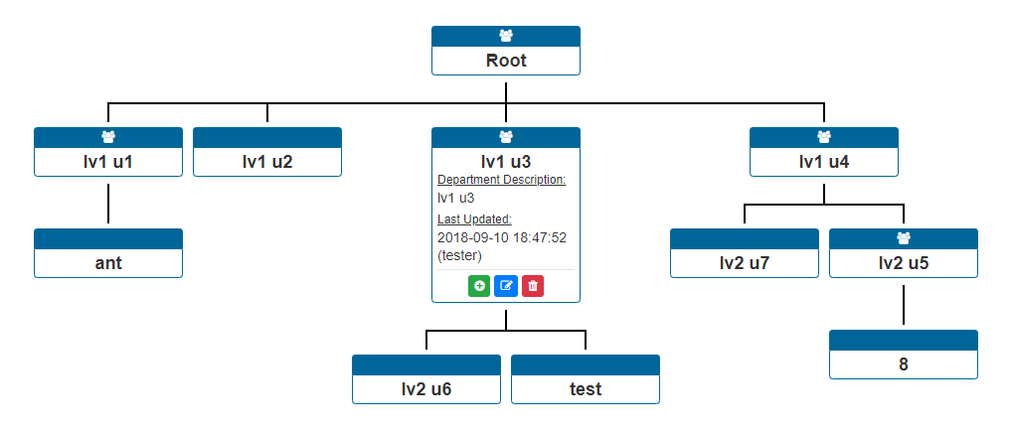
4. Click to add/edit/delete department.   
   The department of the current user is not deletable.   
   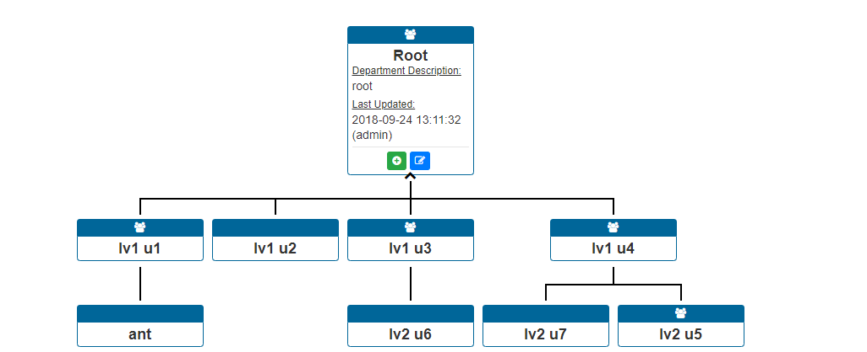

## Email Notification Maintenance

1. Select "Email Notification" under settings.   
   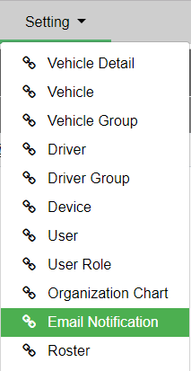
2. Toggle  can switch on email subscription of the corresponding report.   
   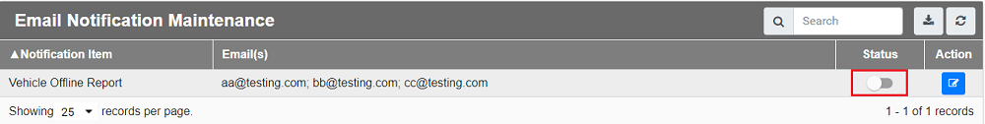
3. Click  can edit the recipient list.   
   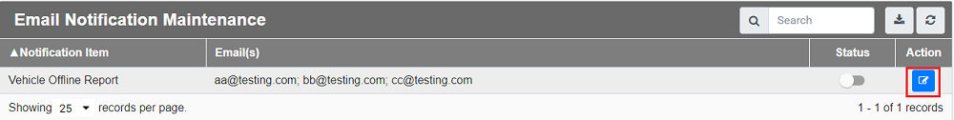
4. Click  to remove the email address from the subscription list.   
   If you want to add a new email address to the list, fill the new email address in the input box and click  . Click OK.   
   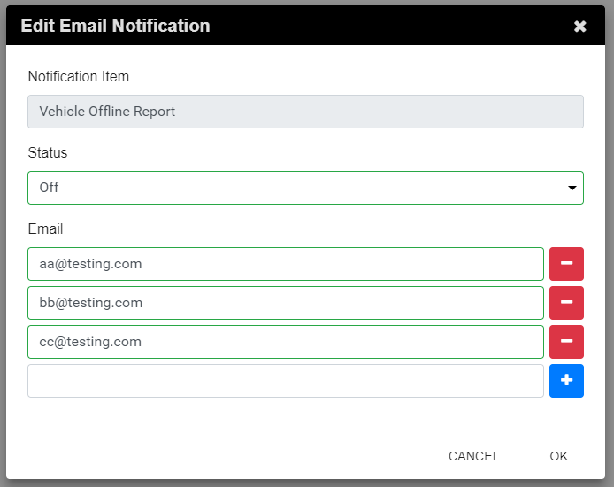
5. If you want to receive reports that are not shown, please contact us.

## Roster

1. Select "Roster" under "Setting".   
   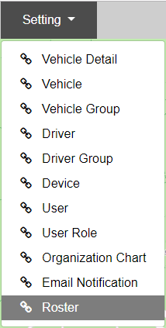
2. Copy the prepared roster to the textarea. Click "submit".   
   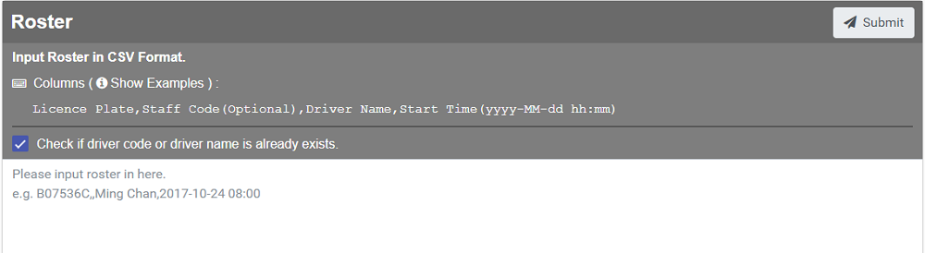
3. Confirmation message will be prompted upon successful submission.   
   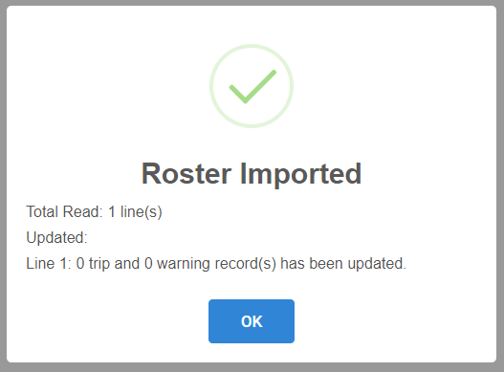
4. Check if the driver name is added under live warning.   
   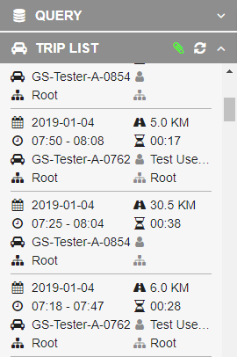

# Abbreviations and Symbols

## Warning Type

|  |  |  |  |  |
| --- | --- | --- | --- | --- |
| **Warning Type** | **Button** | **Marker** | **Fullname** | **Description** |
| **FCW** |  |  | Forward Collision Warning | Alerts driver to react and avoid collision when the risk of an impending forward collision with vehicle/pedestrian/obstacles is too high. |
| **LDW** |  |  | Lane Departure Warning | Alerts driver when the car begins to swerve from the driving lane without turning on direction indicator signal. |
| **HMW** |  |  | Headway Monitoring Warning | Alerts driver when the headway is less than predefined distance (in seconds) value. |
| **AAW** |  |  | Abrupt Acceleration Warning | Vehicle speed accelerated over predefined speed change value within a second. |
| **ABW** |  |  | Abrupt Braking Warning | Vehicle speed decelerated over predefined speed change value within a second. |
| **ATW** |  |  | Abrupt Turning Warning | The centripetal acceleration over predefined value within two seconds. |
| **DWW** |  |  | Drowsing Warning | Alerts driver when the driver is drowsy lasting longer than predefined duration value. |
| **YW** |  |  | Yawning Warning | Alerts driver when the driver is yawning lasting longer than predefined duration value. |

## Driver Action

|  |  |
| --- | --- |
| **Symbols** | **Description** |
|  | Turn on left indicator |
|  | Turn on right indicator |
|  | Brakes |

## Vehicle Type

|  |  |  |
| --- | --- | --- |
| **Vehicle Type** | **Vehicle Icon** | **Vehicle Type Code (For Importing multiple items)** |
| **Car** |  | 1 |
| **Van** |  | 2 |
| **Mini-Bus** |  | 3 |
| **Bus** |  | 4 |
| **Truck** |  | 5 |
| **Concrete Truck** |  | 6 |
| **Others** |  | 7 |

# Appendix

## Grading and Score

|  |  |
| --- | --- |
| **Score range** | **Grade** |
| **90.00 - 100** | A+ |
| **80.00 - 89.99** | A |
| **70.00 - 79.99** | A- |
| **60.00 - 69.99** | B+ |
| **50.00 - 59.99** | B |
| **40.00 - 49.99** | B- |
| **30.00 - 39.99** | C |
| **20.00 - 29.99** | D |
| **10.00 - 19.99** | E |
| **00.00 - 09.99** | F |

## 

## All Recommendations

|  |  |
| --- | --- |
| **Warnings** | **Recommendations** |
| FCW | Pay attention to the pedestrians / vehicles / obstacles in front and slow down when necessary. Avoid driving towards the pedestrians / vehicles / obstacles with high speed. |
| LDW | Avoid swerving from driving lane. Give a direction signal before switching lanes. |
| HMW | Leave a long enough headway between your vehicle and the front vehicle. Avoid staying too close. |
| AAW | Avoid sudden acceleration when driving. |
| ABW | Avoid sudden braking. When there is a changing traffic light, save plenty of time for slowing down. |
| ATW | Avoid cornering with high speed, slow down during cornering when needed. |
| DWW | Pay attention to road situation during driving, avoid fatigue driving. |
| YW | Get sufficient sleep before driving, avoid fatigue driving. |